**Report on Network Cabling, IP Configuration, and Network Tools**

**BY SAMYAK MISHRA**

**13000122008**

## **Table of Contents**

1. **CAT-5/CAT-6 Cable Preparation with RJ-45 Connectors**
   * **1.1 Overview**
   * **1.2 Required Tools and Materials**
   * **1.3 Step-by-Step Cable Preparation**
   * **1.4 Straight-Through vs. Crossover Cabling**
   * **1.5 Illustrations and Diagrams**
2. **IP Address Configuration on Linux and Windows Systems**
   * **2.1 Windows IP Configuration (Static and DHCP)**
   * **2.2 Linux IP Configuration (Static and DHCP)**
   * **2.3 Screenshots and Examples**
3. **Introduction to Network Tools and Commands**
   * **3.1 ipconfig (Windows)**
   * **3.2 ifconfig (Linux)**
   * **3.3 ip (Linux)**
   * **3.4 hostname**
   * **3.5 ping**
   * **3.6 netstat**
   * **3.7 route**
   * **3.8 traceroute / tracert**
   * **3.9 tcpdump**
   * **3.10 Wireshark**
4. **Conclusion**

## 

## **1. CAT-5/CAT-6 Cable Preparation with RJ-45 Connectors**

### **1.1 Overview**

**CAT-5 and CAT-6 cables are standard twisted-pair cables used for Ethernet networks. They are terminated using RJ-45 connectors, which provide the physical interface between the cable and networking hardware. There are two main wiring schemes:**

* **Straight-through cabling: Used to connect dissimilar devices (e.g., computer to switch).**
* **Crossover cabling: Used to connect similar devices directly (e.g., PC to PC).**

### **1.2 Required Tools and Materials**

* **Cable Stripper/Scissors: For removing the outer jacket.**
* **RJ-45 Connectors: Available for CAT-5 or CAT-6.**
* **Crimping Tool: To secure the connector to the cable.**
* **Cable Tester (optional): To verify correct termination.**
* **Cutting Tool: For measuring and cutting the cable to length.**

### **1.3 Step-by-Step Cable Preparation**

1. **Measure and Cut:  
   Determine the required length and cut the cable cleanly.**
2. **Strip the Cable Jacket:  
   Using a cable stripper, remove approximately 1–2 inches of the outer jacket, exposing the twisted pairs inside.**
3. **Untwist and Arrange the Pairs:**
   * **Gently untwist the pairs and straighten them.**
   * **Arrange the individual wires in the correct order according to the desired wiring standard:**
     + **T568A Standard: White/Green, Green, White/Orange, Blue, White/Blue, Orange, White/Brown, Brown.**
     + **T568B Standard: White/Orange, Orange, White/Green, Blue, White/Blue, Green, White/Brown, Brown.**
   * ***Note:* Both ends must follow the same standard for a straight-through cable. For a crossover cable, one end is wired as T568A and the other as T568B.**
4. **Trim the Wires:  
   Align the wires evenly and trim them to an equal length, ensuring that all wires extend about 0.5 inches from the jacket.**
5. **Insert the Wires into the RJ-45 Connector:  
   Carefully insert the wires into the connector, ensuring that each wire lands in the correct channel and that the cable jacket is inserted firmly to secure strain relief.**
6. **Crimp the Connector:  
   Use the crimping tool to press the connector firmly onto the cable. The internal metal pins should pierce the insulation of each wire, securing them in place.**
7. **Test the Cable:  
   Optionally, use a cable tester to verify that the wiring is correct and that there are no continuity or miswiring issues.**

### **1.4 Straight-Through vs. Crossover Cabling**

* **Straight-Through Cable:  
  Both connectors use the same wiring standard (T568A or T568B).  
  *Usage:* Connects devices of different types (e.g., PC to switch).**
* **Crossover Cable:  
  One connector uses T568A while the other uses T568B. This configuration swaps the transmit and receive pairs.  
  *Usage:* Connects similar devices directly (e.g., switch to switch or PC to PC).**

### **1.5 Illustrations and Diagrams**

* **Wiring Diagrams:**
  + ***T568A and T568B Pinouts:***
* **Cable Preparation Workflow:  
  [Insert step-by-step diagram or series of screenshots showing cable stripping, wire arrangement, insertion into RJ-45, and crimping.]**
* **Cable Tester Screenshot:  
  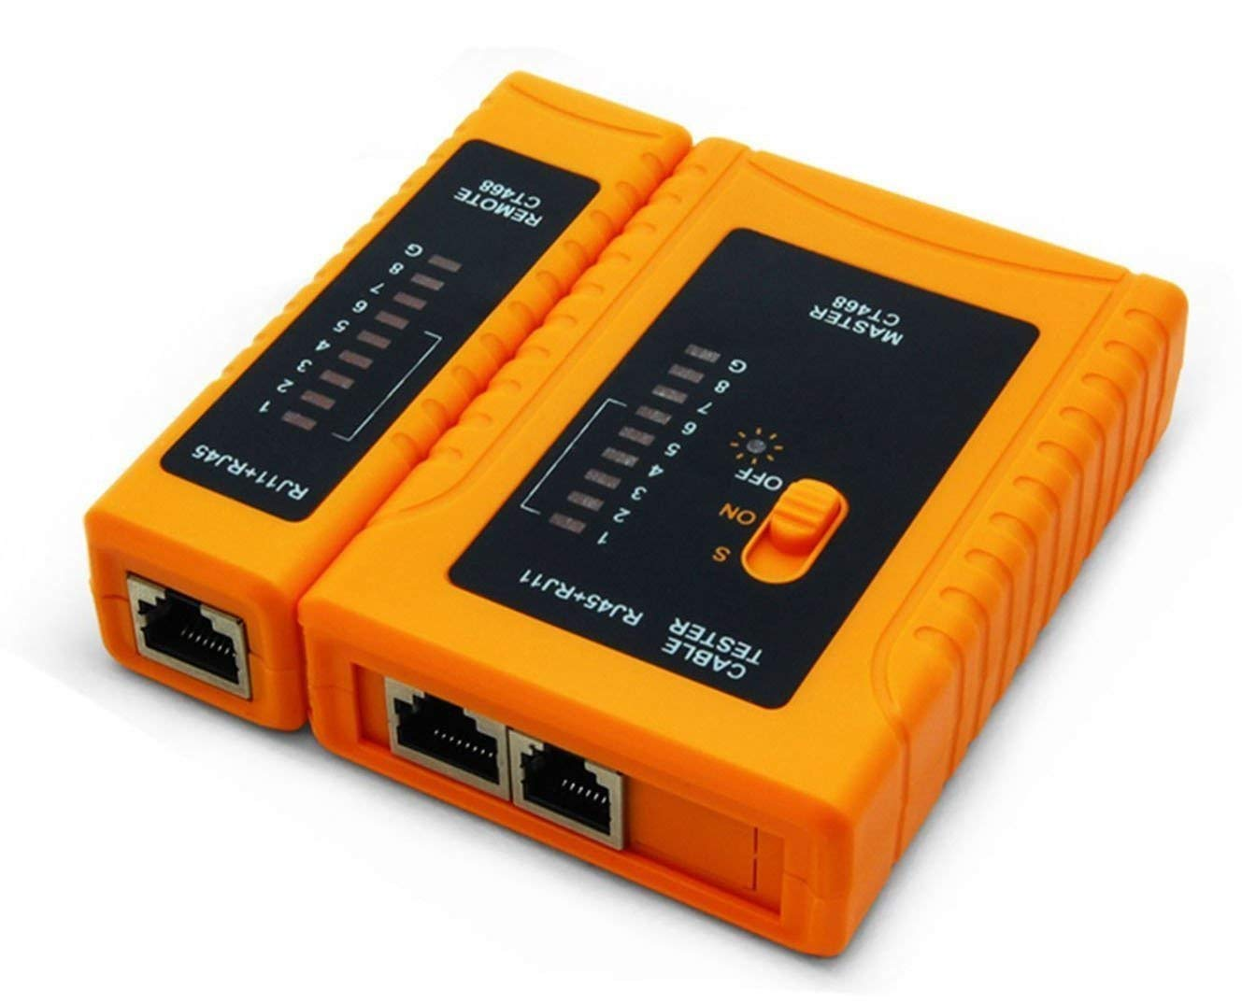**

## **2. IP Address Configuration on Linux and Windows Systems**

### **2.1 Windows IP Configuration**

#### **Static IP Configuration:**

1. **Using the GUI:**
   * **Open Control Panel > Network and Sharing Center.**
   * **Click on Change adapter settings.**
   * **Right-click the network adapter and select Properties.**
   * **Select Internet Protocol Version 4 (TCP/IPv4) and click Properties.**
   * **Choose Use the following IP address and enter:**
     + **IP Address: (e.g., 192.168.1.100)**
     + **Subnet Mask: (e.g., 255.255.255.0)**
     + **Default Gateway: (e.g., 192.168.1.1)**
   * **Optionally, fill in the DNS server addresses.**
   * **Click OK to save the configuration.**
2. ***Screenshot Suggestion:* Capture the “TCP/IPv4 Properties” window showing static IP configuration.**
3. **Using Command Prompt:**
   * **Open Command Prompt as an administrator.**

**Use the following command (modify parameters as needed):  
netsh interface ip set address name="Ethernet" static 192.168.1.100 255.255.255.0 192.168.1.1**

#### **DHCP Configuration:**

1. **Using the GUI:**
   * **In the TCP/IPv4 Properties window, select Obtain an IP address automatically and Obtain DNS server address automatically.**
   * **Click OK.**
2. **Using Command Prompt:**

**Release the current IP address:  
ipconfig /release**

**Renew the IP address:  
ipconfig /renew**

### **2.2 Linux IP Configuration**

#### **Static IP Configuration:**

1. **Temporary Configuration Using ifconfig/ip (requires sudo privileges):**

**Using ifconfig (older method):  
sudo ifconfig eth0 192.168.1.100 netmask 255.255.255.0**

**sudo route add default gw 192.168.1.1**

**Using ip (recommended):  
sudo ip addr add 192.168.1.100/24 dev eth0**

**sudo ip route add default via 192.168.1.1**

1. **Permanent Configuration:**

**Edit the network configuration file (e.g., /etc/network/interfaces for Debian/Ubuntu):  
auto eth0**

**iface eth0 inet static**

**address 192.168.1.100**

**netmask 255.255.255.0**

**gateway 192.168.1.1**

**dns-nameservers 8.8.8.8 8.8.4.4**

**Restart the networking service:  
sudo systemctl restart networking**

#### **DHCP Configuration:**

1. **Temporary Configuration:**

**Use the DHCP client:  
sudo dhclient eth0**

1. **Permanent Configuration:**

**Modify the /etc/network/interfaces file to use DHCP:  
auto eth0**

**iface eth0 inet dhcp**

**Restart networking:  
sudo systemctl restart networking**

1. ***Screenshot Suggestion:* Capture terminal output when running dhclient.**

### **2.3 Screenshots and Examples**

* **Windows:**
  + **Command Prompt output of ipconfig /all.**
* **Linux:**
  + **Terminal screenshots showing the use of ifconfig or ip addr show.**

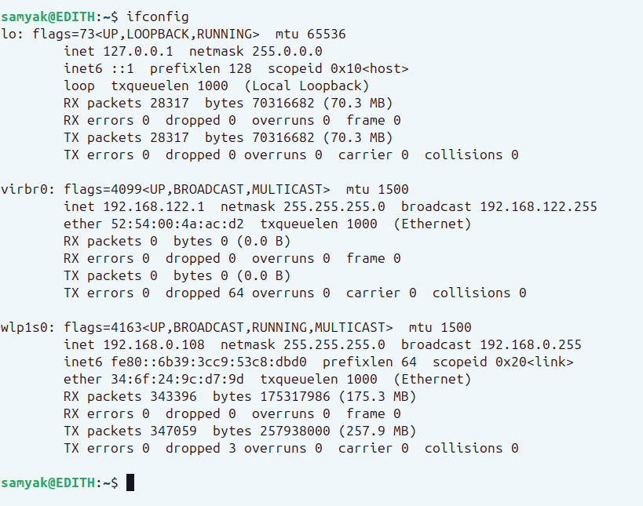

## **3. Introduction to Network Tools and Commands**

### **3.1 ipconfig (Windows)**

* **Description:  
  Displays all current TCP/IP network configuration values and refreshes DHCP and DNS settings.**

**Example Usage:  
ipconfig /all**

* ***Output Example:*Lists IP address, subnet mask, default gateway, and DNS servers.**

### **3.2 ifconfig (Linux)**

* **Description:  
  Displays or configures a network interface (older tool; many modern distributions now use the ip command).**

**Example Usage:  
ifconfig -a**

* ***Output Example:*Shows all network interfaces and their configurations.**

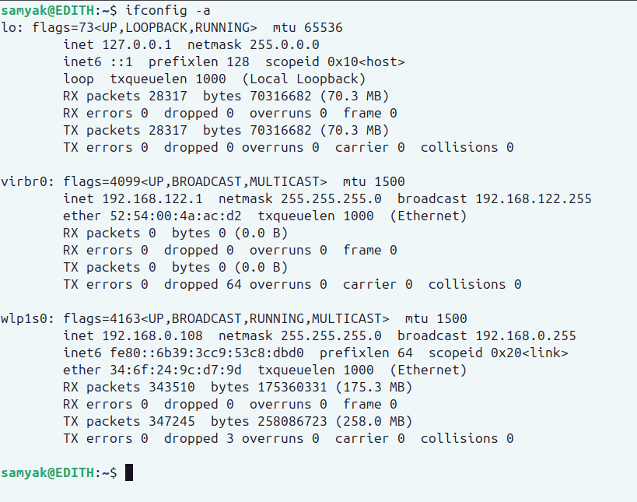

### **3.3 ip (Linux)**

* **Description:  
  A modern and versatile utility for network configuration and management.**
* **Example Usages:**

**Display all IP addresses:  
ip addr show**

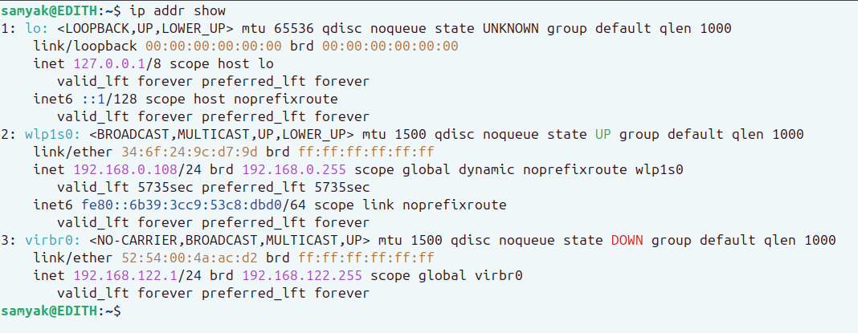

**Show routing table:  
ip route show**

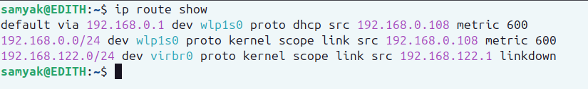

### **3.4 hostname**

* **Description:  
  Displays or sets the system’s host name.**

**Example Usage:  
hostname**

**On Linux, use hostnamectl for more details or to set a new hostname:  
sudo hostnamectl set-hostname new-hostname**

### **3.5 ping**

* **Description:  
  Tests network connectivity between the host and a destination IP address or domain.**

**Example Usage:  
ping google.com**

* ***Output Example:*Sends ICMP echo requests and displays the round-trip time.**

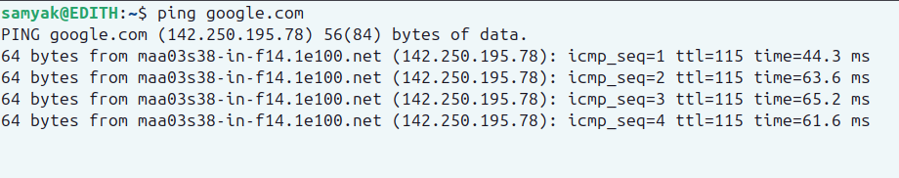

### **3.6 netstat**

* **Description:  
  Displays active connections, listening ports, and network statistics.**

**Example Usage:  
netstat -an**

* ***Output Example:*Lists all active connections and open ports.**

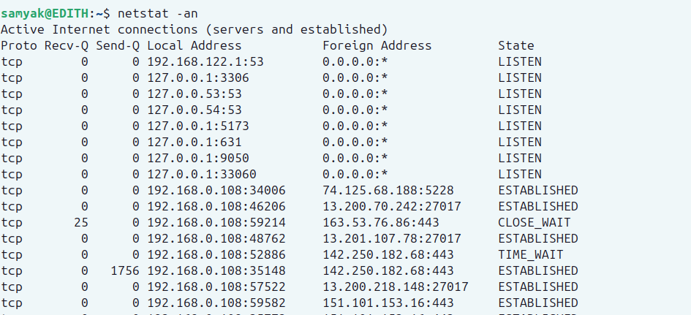

### **3.7 route**

* **Description:  
  Displays or manipulates the IP routing table.**

**Example Usage:  
route -n**

* ***Output Example:*Shows routing table entries in a numerical format.**

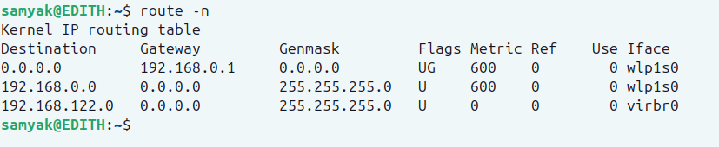

### **3.8 traceroute / tracert**

* **Description:  
  Determines the path packets take to a network host.**
* **Example Usage:**

**Windows (tracert):  
tracert google.com**

**Linux (traceroute):  
traceroute google.com**

* ***Output Example:*Lists each hop along the route with round-trip times.**

### **3.9 tcpdump**

* **Description:  
  A powerful command-line packet analyzer that captures network packets in real time.**

**Example Usage:  
sudo tcpdump -i eth0**

* ***Output Example:*Displays captured packet details such as source, destination, and protocol type.**

### **3.10 Wireshark**

* **Description:  
  A graphical network protocol analyzer that allows detailed inspection of network traffic.**
* **Example Usage:**
  + **Start Wireshark, select the network interface, and begin capturing packets.**
  + **Use filters (e.g., http, tcp.port==80) to focus on specific traffic.**
* ***Screenshot***

